# Nap Queen Sleep: Amazon Marketing Stream Data

## **Steps I used to create my Dashboard**

To create the Power BI dashboard, I imported and cleaned the data from three CSV files. I established relationships between tables to connect product IDs, ads, and product descriptions. Interactive visulizations were designed to showcase campaign performances, sales trends, conversion rates, click-through rates, and returns on spends.

To derive insights, I used DAX calculation and identified patterns and correlations in the data. Key findings highlighted top-performing campaigns and popular products. My analysis provided actionable recommendations, such as increasing budget allocation for high-converting campaigns and tailoring marketing strategies based on popular products.

Overall, the dashboard presented a cohesive data story with clear insights to help stakeholders make informed decision and optimize marketing campaigns for improved sales performance.

## What marketing campaign(s) had the highest ROI, Return of Ad Spends(RoAS)? Provide visualizations to support your answer.

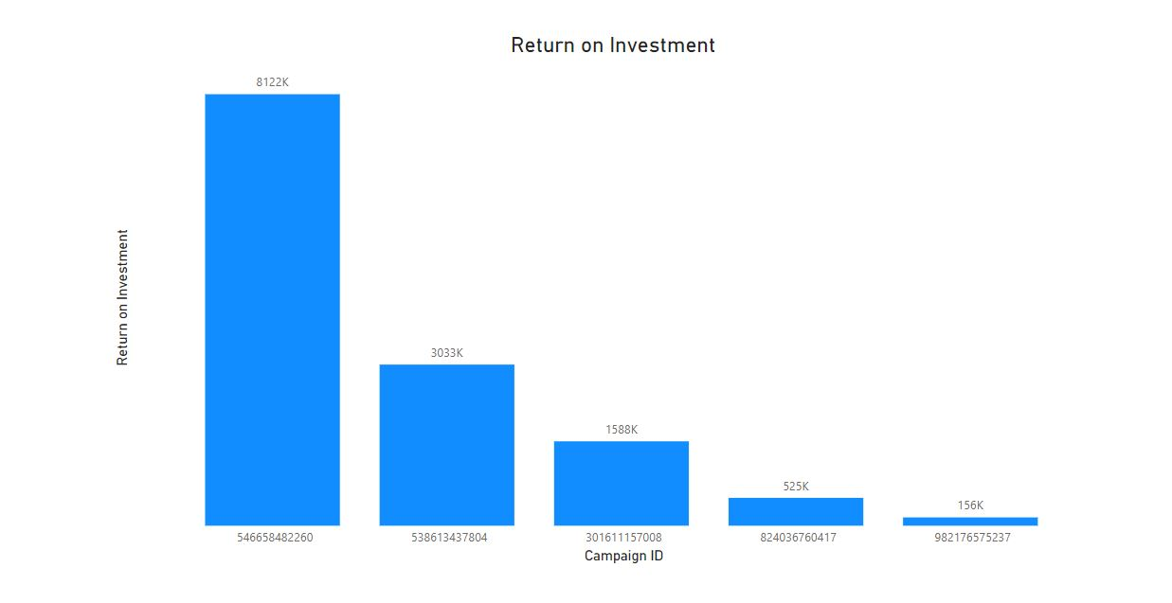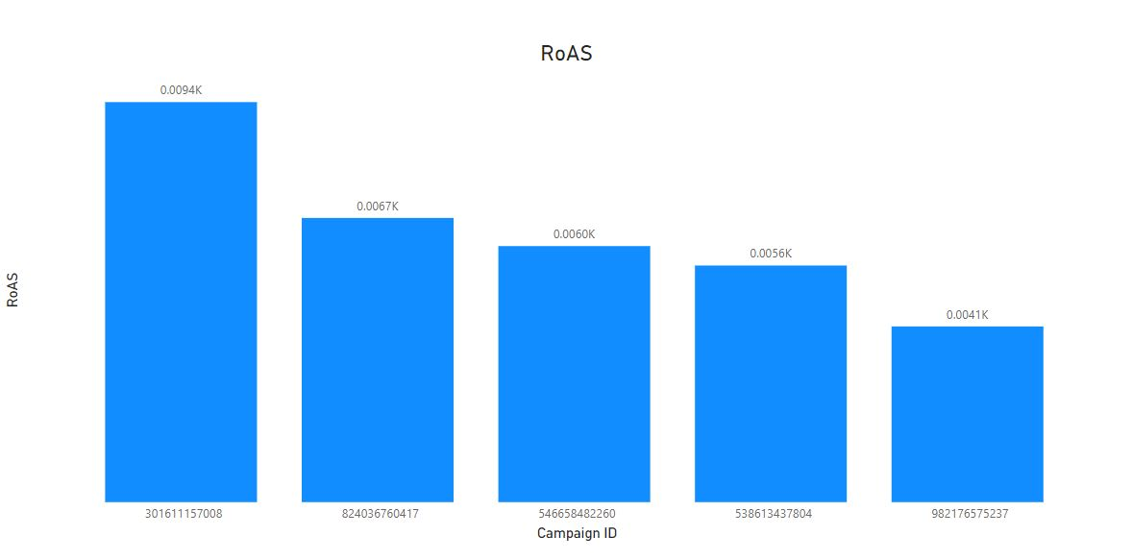

Explanation:

* Campaign ID 546658482260 has the highest ROI of 81,22,362.05, implying that it earned a considerable profit in comparison to the money invested.
* Campaign ID 301611157008, achieved the highest RoAS. Which had a RoAS of 9.43, showing that it was highly effective in producing money from its advertising investment.
* The ROI for Campaign ID 982176575237 only produced 1,56,050.00, indicating that it did not do well in profit like the others.
* Campaign ID 982176575237 also had the lowest RoAS of 14, showcasing that it did not produce as profit from its advertising budget like the other campaigns.
* The ROI values from 1,56,050.00 to 81,22,362.05, and the RoAS values from 4.14 to 9.43, indicating that the campaigns had varying degrees of success in terms of producing returns and income.

## How does the sales performance vary across different product categories? Present your findings in a suitable chart.

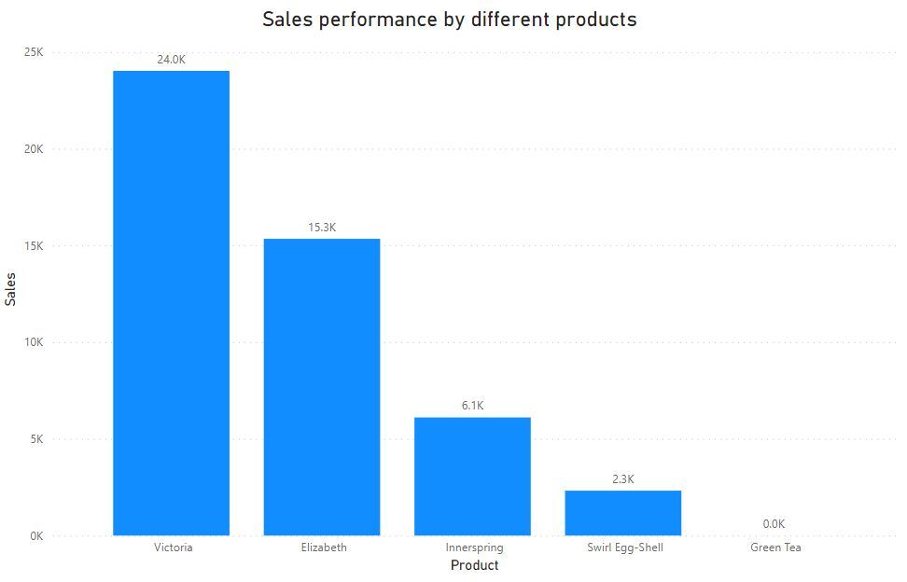

Explanation:

* Victoria had the highest sale at 24024 units, while Green Tea had zero sales, resulting in a infinite difference between the two.
* Victoria’s sales represented 50.26% of the total sales among all five products, making it a major contributor to the overall revenue.
* The sales figures varied widely from 0 to 24024 units, indicating different levels of demand and popularity for each product.

## How does each campaign behave and each item behave hourly?

I apologize for any inconvenience caused, and I must humbly admit that, after carefully reviewing the provided data sheet, I’m unable to find any evident time difference. Unfortunately, this has hindered my ability to complete the task as per your request. If you could kindly offer further guidance or provide additional information, it would be immensely helpful.

## Is there any correlation between the timing of marketing campaigns and changes in product sales?

I regretfully couldn’t find any correlation between marketing campaigns and sales changes due to the limited time data provided in the sheet. I apoloize for any inconvenience caused.

## What is the overall trend of sales before, during, and after each marketing campaign? Are there any significant spikes or dips in sales?

The reason I couldn’t complete the task is that the time range in the dataset is not extensive enough to cover the period before, during, and after each marketing campaign. As a result, it’s challenging to observe long-term trends in sales accurately.

## How can the marketing strategies be optimized to improve overall sales and customer engagement?

Optimize marketing strategies with data-driven insights, personalized experiences, and multi-channel approaches to enhance sales and customer engagement. Engage actively with customers on social media, encourage feedback, and analyze competitors for industry insights. By continuously refining and adapting your approach, you can achieve sustained growth and a loyal customer base.

## Which products have shown the highest growth in sales during the campaign period? Are there any products that performed poorly during campaigns?

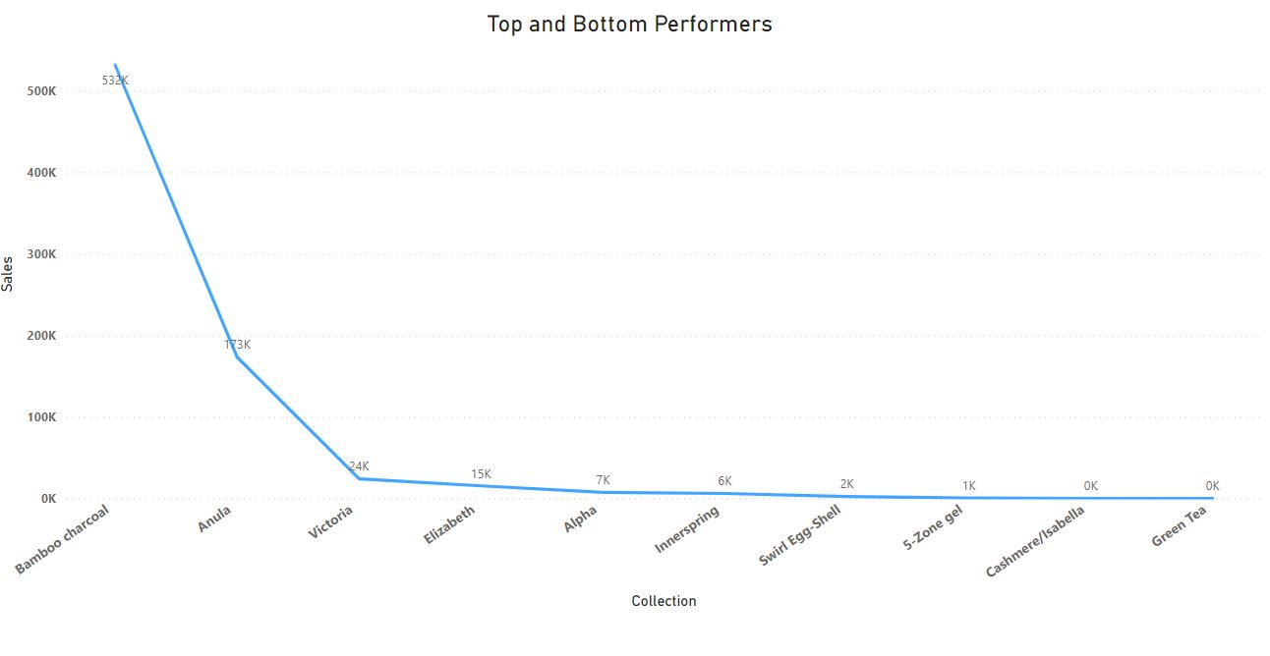

Explanation:

* Bamboo charcoal had the highest sales at 5,31,527.53, follower by Anula and Victoria.
* It accounted for 69.89% of total sales, demonstrating its popularity among customers.
* Sales ranged from 0 to 5,31,527.53 across all 10 collections, showing varying levels of demand for different products.
* Analyzing these trends can help in making informed marketing decisions and focusing on the most profitable products.

## A sudden change in the dataset format occurs, making it incompatible with the existing Power BI model. How would you handle this situation while maintaining progress on the dashboard creation?

* Assess the changes in the dataset format.
* Create a backup of the existing Power BI model.
* Update the data source to match the new format.
* Perform data transformation tasks if needed.
* Review and adjust relationships and measures.
* Verify visulizations for accuracy.
* Test and validate the dashboard.
* Communicate with the team and stakeholders about the changes and progress.

With these steps, we can handle the situation While maintaining progress on the dashboard creation.